# CS 255 – DriverPass – Project 2

## UML Diagrams

### UML Use Case Diagram

### UML Activity Diagrams covering Customer registration & DMV notifications

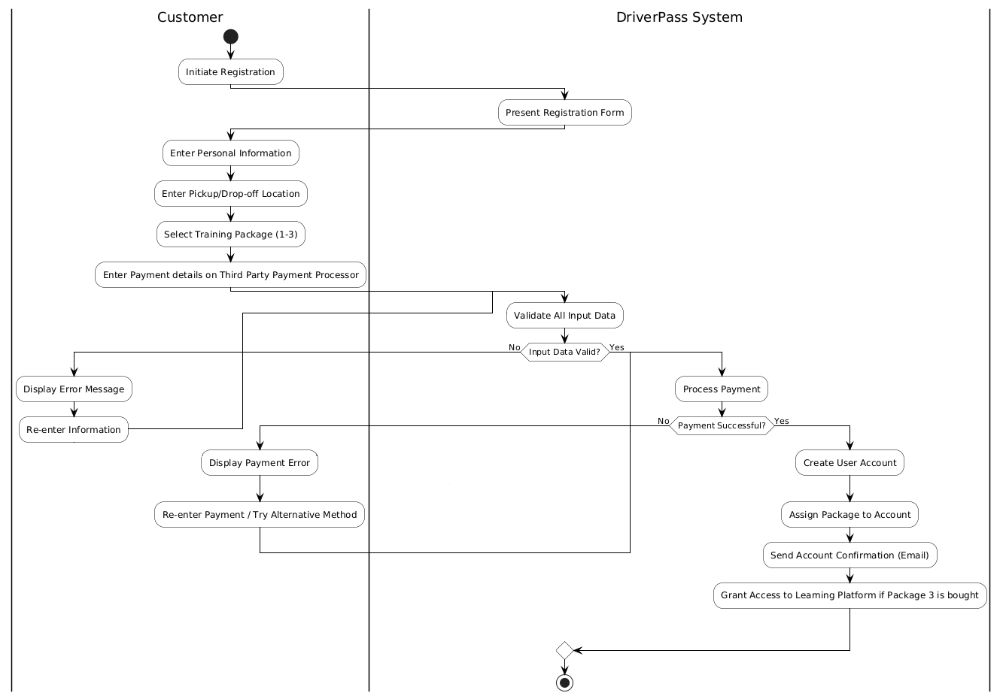

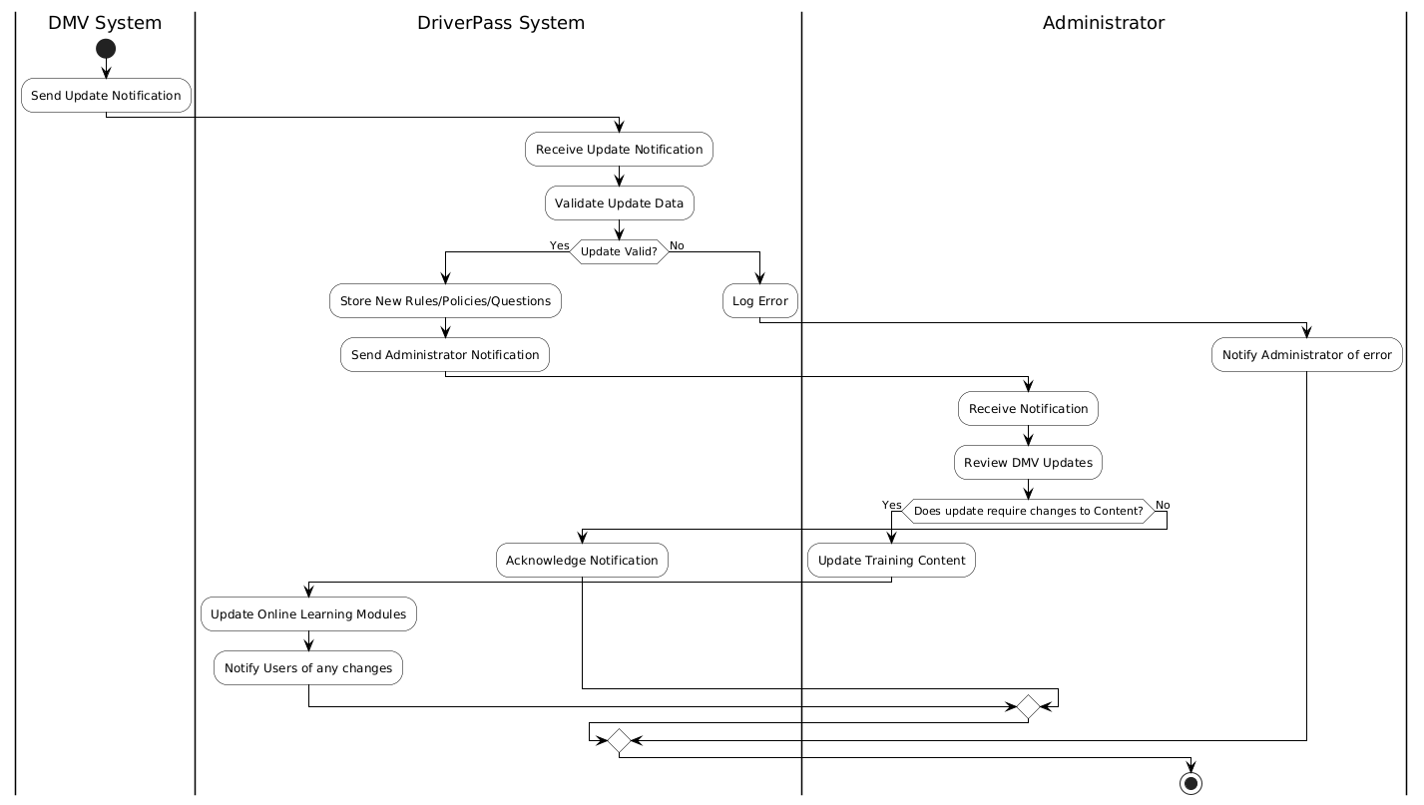

### UML Sequence Diagram

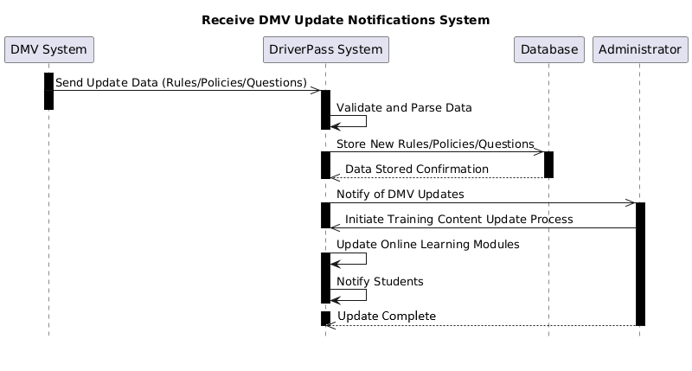

### UML Class Diagram

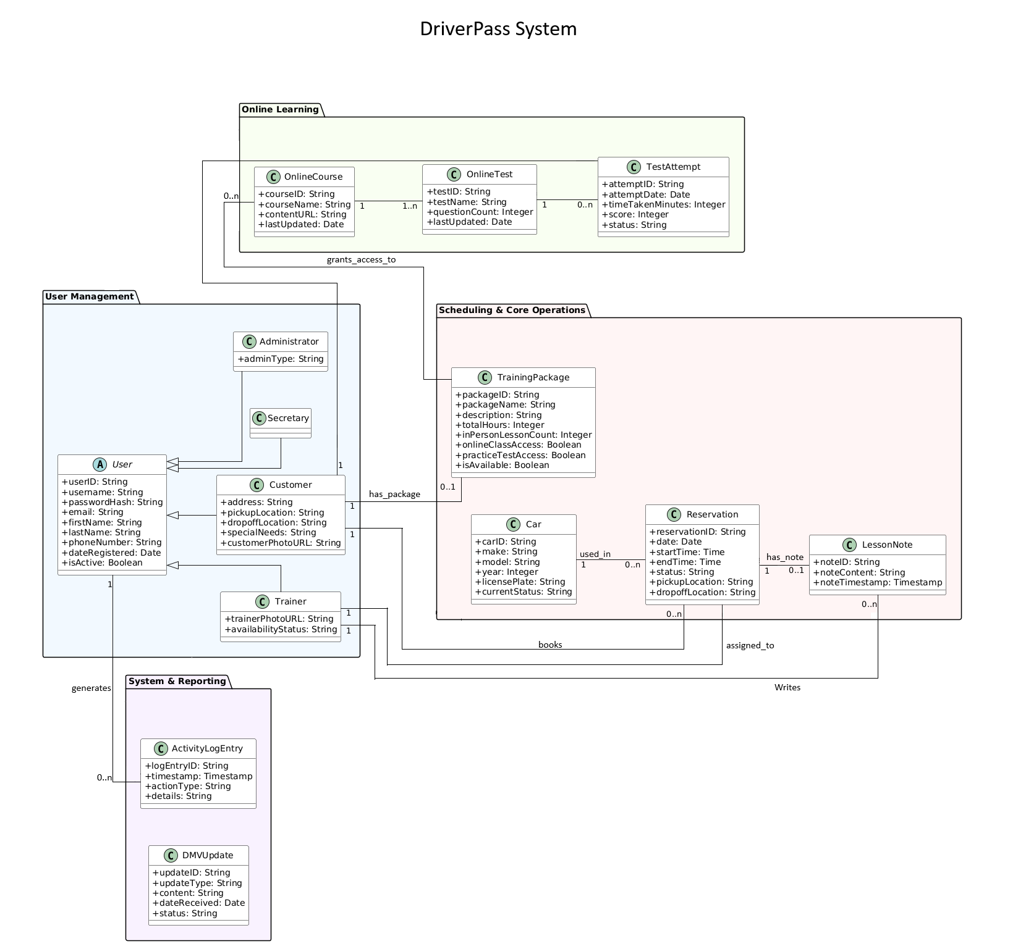

## Technical Requirements

External Connections:

* + The system shall be seamlessly connected with all key external systems. It will integrate with the DMV via an API to automatically receive the latest rulings on any policy changes, driving laws, and sample questions.
  + The system shall maintain up-to-date training and compliance with the local regulations with the DMV that pertains to the user.
  + The system shall connect with a third-party payment processor for all transactions inside the system.

Secure Data:

* The system shall use a database management solution that securely stores all required information such as user information, customer details, course content, student activity logs, student progress, scheduling information, and instructor vehicle information.

Security and User Role Access:

* The system shall implement the highest level of security possible by using a secure authentication process for all users, regardless of role.
* The system shall assign a role to each user and restrict access to the system based on that role.
* The system shall log all important user activities allowing an individual user or the entire user base to be audited if needed.

Online Platform:

* The system shall operate on a secure cloud-based platform that allows users access from a computer or phone
* The platform we chose shall maintain the highest level of up-time possible to maintain user accessibility
* The platform shall include automated backups to prevent any data loss disasters.
* The platform shall handle all IT related management, which includes security, hardware upgrades, and preventing attacks on the system.